Laurent series

$$\left[def\right]$$

$$It is given by$$

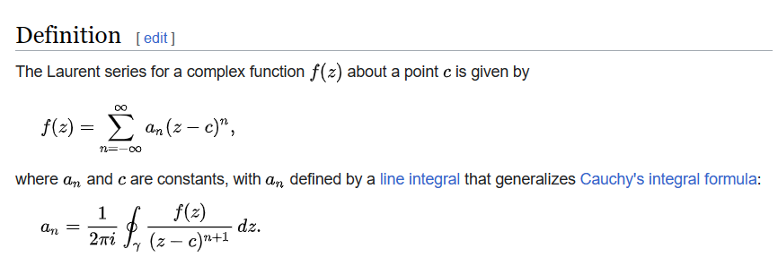

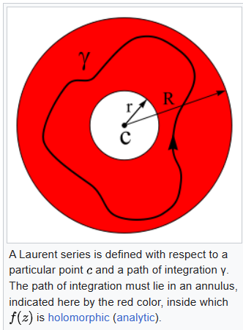

Ref:

[Laurent series - Wikipedia](https://en.wikipedia.org/wiki/Laurent_series)